

Name : Pang Sheng Wei

Login ID : **R03412907@oasis-portal.my**

Course title : Executive Diploma in Culinary Arts & Hospitality Management

Subject Code : CA03 INTERNATIONAL CUISINE

Submitted date: 0**7/September/ 2017**

**Table of Contents**

|  |  |  |
| --- | --- | --- |
| **No** | **Details** | **Page** |
| 1 | Executive Summary | 2 |
| 2 | Introduction | 3-4 |
| 3 | Assignment Question | 5 |
|  | Part 1 | 6-14 |
| 4 | Conclusion | 15 |
| 5 | References | 16 |

**Executive Summary**

In this assignment, I learn how to make a make a purpose and via this unit of point I understand that International Cuisine is not content with Culinary Arts and Hospitality Management.

In this project, I was assigned to cook a dish form each cuisine. The dish I cook to represent Chinese cuisine is dumpling, Western cuisine is carbonara, Indian cuisine is Chicken Varuval. From each cuisine, I was recreated or make up my own secret recipe compare to the original recipe.

By doing this exercise, I learn each different kinds form western. Western food can be divided into: French, British, Italian, Russian, American and other major categories. Western knives commonly used in the main knife, slices, chop, split (cut), shoot, cut and the beautiful fancy furnishings of Western food.

**Introduction**

### International cuisine means food that food that comes from different countries which represented their traditional food or culture example show as below:

### Vietnam

* Pho GA
* Goi Cuon
* Banh mi
* Banh Xeo
* Bun Cha

Italian

* [Capers Salad with Pesto Sauce](http://food.ndtv.com/recipe-caprese-salad-with-pesto-sauce-233322)
* [Panzenella](http://food.ndtv.com/recipe-panzenella-294776)
* [Bruschetta](http://food.ndtv.com/recipe-bruschetta-239382)
* [Focaccia Bread](http://food.ndtv.com/recipe-focaccia-bread-146148)
* [Pasta Carbora](http://food.ndtv.com/recipe-pasta-carbonara-294772)

### Korean

* Hangover Stew
* Kimchi
* Soft Tofu Stew
* Chimaek
* Instant noodles

Western

* Chicken Chop
* Rib Eye Steak
* Lamb Steak
* Pock Chop
* Fish & Chip

Chinese Food

* Fried Rice
* Dumpling
* Beef With Broccoli
* Mapo Dofu
* Chicken Chow Mein

**Assignment Questions**

You should create your own dish from each international cuisine listed.

Required:

Choose one dish for each cuisine:

1. Chinese cuisine
2. Indian Cuisine
3. Western Cuisine

**(I) Original Chinese Cuisine**

Dumpling

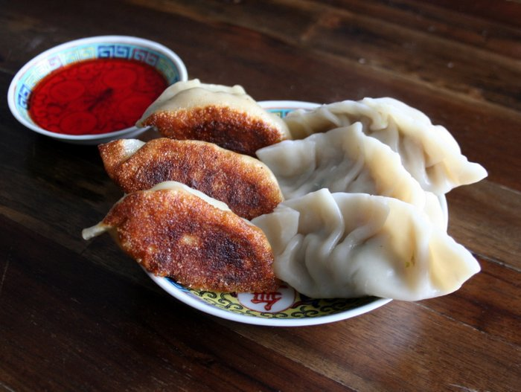

Ingredients:

12 ounces cabbage  
1/2 teaspoon salt  
1 teaspoon fresh ginger  
2 green onions  
2/3 pound ground pork  
1/8 teaspoon ground black pepper  
1 1/2 tablespoons soy sauce  
1 tablespoon Shaoxing rice wine  
2 teaspoons sesame oil  
30 dumpling wrappers

Directions

1. Finely mince the cabbage in a food processor. Place in a large bowl, sprinkle with the salt and set aside for 10 minutes.

2. Add the pork, ginger, green onion, pepper, soy sauce, rice wine and sesame oil to the food processor. Pulse 5 times until the ingredients are combined well. Set aside.

3. Place the cabbage on a kitchen cloth, twist the top and squeeze out as much liquid as you can. Add the dry cabbage to your pork mixture and combine.

4. Spoon 1 tablespoon of the pork and cabbage mixture in the center of each dumpling wrapper. To wrap a dumpling, dab water along the inside edge of the wrapper, fold in half to form a semicircle enclosing the filling, then seal the edges together to stick. Finally, fold 5-6 small pleats around the top edge of the dumpling. Repeat until all of your dumplings are done.

5. Separate the dumplings you’ll need for your meal and then freeze the rest in a heavy plastic bag for later.

6. There are two easy ways to cook dumplings.

– To boil: Bring a large pot of water to a boil. Add 15 dumplings to the pot and boil for 9 minutes, stirring occasionally to prevent them from sticking to the bottom of the pot. Remove the dumplings from the heat and drain, repeating with any remaining dumplings.

– To fry: Heat a tablespoon of oil in a frying pan over medium-high heat. Place 15 dumplings in a single layer and fry for 2 minutes. Turn the heat down to low, add 1/3 cup of water, cover and steam for 5 minutes. Uncover, return heat to medium-high and fry until the water has evaporated. Remove the dumplings from the heat, repeating with any remaining dumplings.

7. Serve immediately with chili sauce, red rice vinegar or soy sauce for dipping.

**(i)** OWN Recipe

Dumpling

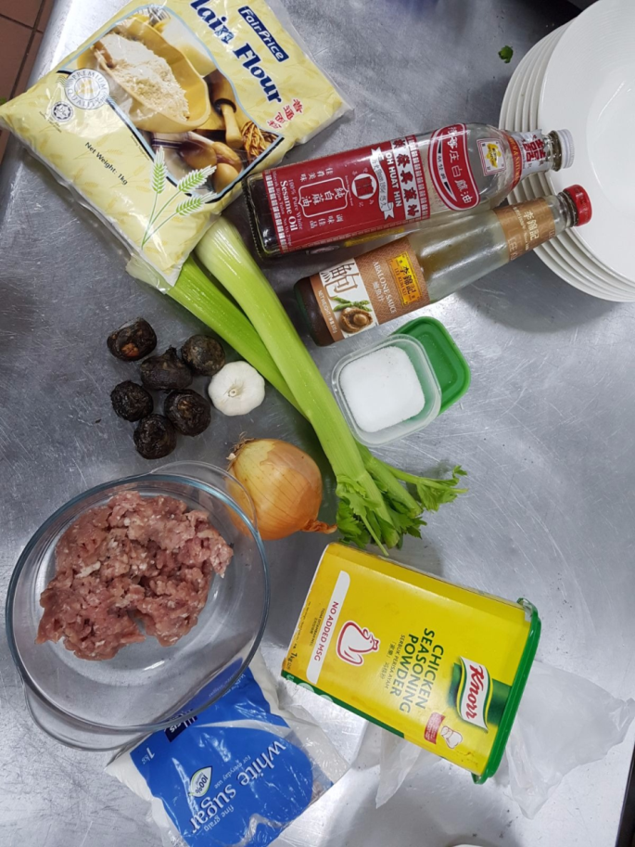Ingredients:

Minced Pork

Onion

Garlic

Sesame Oil

Chicken Powder

Sugar

Abalone Sause

Celery

Water Chestnuts

Plain Flour

Salt

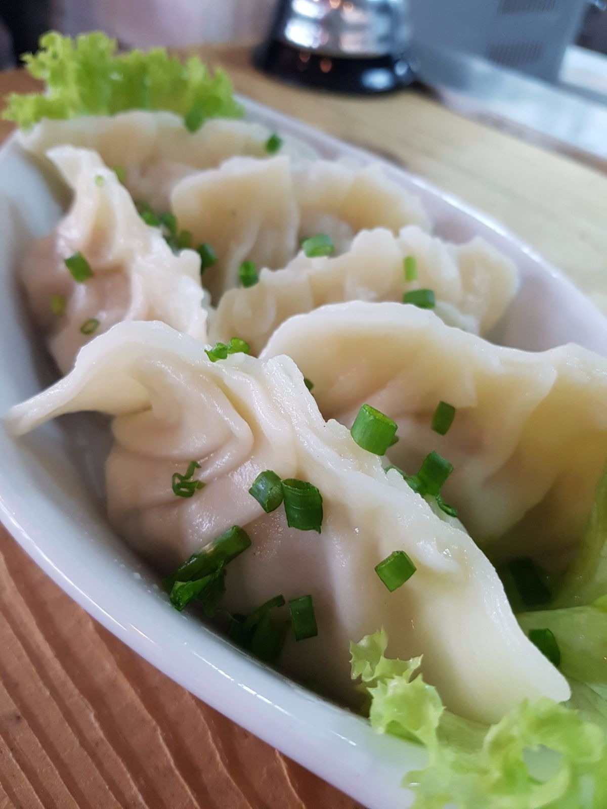

**INSTRUCTIONS**

**To prepare the dough**

Add flour into a large bowl. Slowly pour the water into the bowl, mixing them together with a pair of chopsticks.

When the water is mixed with the flour, dust both hands with flour and start kneading to form dough. The dough will be quite tough and should easily be able to be lifted from the bowl without sticking to the bottom.

When dough has formed, dust the working surface with flour and dust hands again. Transfer the dough to the working surface and continue to knead it until its surface becomes smooth, about 10 minutes.

Rinse a clean dish towel with water. Dust the bottom of a large bowl with flour and transfer the dough into it. Cover bowl with the damp dish towel and a lid (or plastic wrap). Let the dough rest for 2 hours. You can let the dough rest longer, 4 to 5 hours.

After resting, the dough will be softened and have a smooth texture. Dust the working surface and your hands with extra flour and transfer the dough onto the surface. Knead the dough repeatedly for another 3 to 5 minutes, until the dough hardens again. Let the dough rest for about 30 minutes (or longer).

During this time, you can prepare the dumpling filling(s).

**To make dumplings**

1. Dust the working surface again and transfer the dough onto it. Slice 1/6 of the dough off and place the rest back to the big bowl. Cover it with the damp dish towel.
2. Roll the dough into a long stick, 2.5 to 3 centimeters (1 inch) in diameter. Use a knife to cut the dough stick into about 12 small doughs, each weighing 12 to 14 grams (0.4 to 0.5 oz)
3. Slightly dust both sides of each small dough with flour. Work on them one at a time.
4. Dust the working surface again. Take one dough and press it to a round disc. Roll it with a rolling pin into a round sheet. Try to roll it so that that the edge is thinner than the center. The wrapper should be about 1 millimeter thick and the diameter should be about 7 centimeters. It is ok if the wrapper is not perfectly round.
5. Starting here, you should work as quickly as you can, because the wrappers will dry out quickly. And if they do, you will find it very difficult to seal the dumplings later. If the wrappers dry out when you start to fold the dumplings, brush a bit of water over the edge so you can still seal the dough.
6. Scoop about 1 tablespoon (or less, so you can easily fold the dumpling) of dumpling filling and place it in the center of the wrapper. Hold the dumpling with one hand and start sealing the edges with the other hand. Be careful, when you press the edges together to seal the dumpling, do not let filling touch the sealing area (the dumpling will fall apart if you do). After folding, press edge again to seal well. You don’t need to fold beautiful dumplings here; our goal is to make the dumplings hold their shape during boiling.
7. Place the dumplings on the working surface and work on the rest of the doughs in the same manner.
8. Try to wrap and cook dumplings in small batches (20 to 25 dumplings at a time). If you won't cook dumplings soon after wrapping (within 30 minutes), freeze them first. If you want to know the reason, read the session of "Things you should take note of" above.

**To cook boiled dumplings**

1. Bring a large pot of water to a boil.
2. Carefully add dumplings one at a time into the water. Use a big ladle to stir the water gently and continuously, until the water starts to boil again, so the dumplings won’t stick to the bottom, for about 1 minute. Adjust the heat so the water is at boiling point, but isn’t bubbling too fiercely.
3. When the dumplings float to the surface, continue boiling until the dumplings are filled with air and swollen, and the dough starts to become transparent, about 1 minute. Immediately transfer all the dumplings to a plate.
4. Be careful, the dumplings cook quickly and you should always stand beside the pot throughout the boiling process. When the dumplings are cooked, they will start to fall apart within seconds, so transfer them as soon as possible.

(II) Original Indian Cuisine

Chicken Varuval

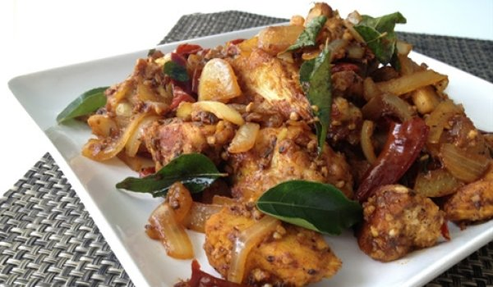Ingredients:

* 1 lb Chicken (cut into pieces)
* 2 Onion (diced)
* 1 tsp Ginger Garlic Paste
* 2 Dry Red Chili
* ½ tsp Cumin Seeds
* 6 Curry Leaves
* 2 tsp Red Chili Powder
* 2 tsp Coriander Powder (dhania powder)
* 2 tsp Black Pepper Powder
* ¼ tsp Turmeric Powder
* Salt to taste
* 3 tbsp Oil

How to make Chicken Varuval:

* Wash and cut the chicken into pieces
* Heat oil in a frying pan and toss cumin seeds, red chillies and curry leaves in to it.
* Add onions and fry it until it turns golden brown along with ginger garlic paste.
* Add chicken along with turmeric powder, red chili powder, coriander powder, black pepper powder and salt to it.
* Cook the mixture on medium flame until the oil separates making the masala slightly thick and dry.

(II)OWN Recipe

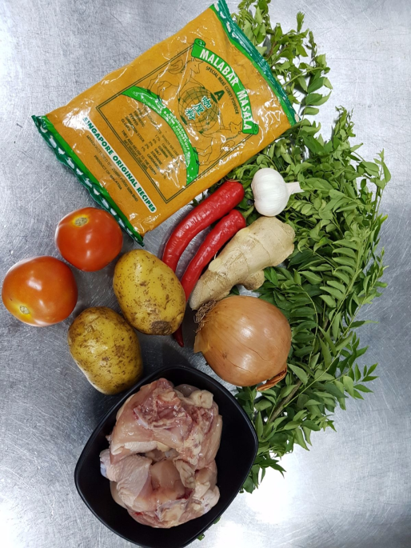Chicken Varuval

**INGREDIENTS**

Curry powder Garlic

Curry leaf Tomato

Onion

Ginger

Chicken

Potato

Chili

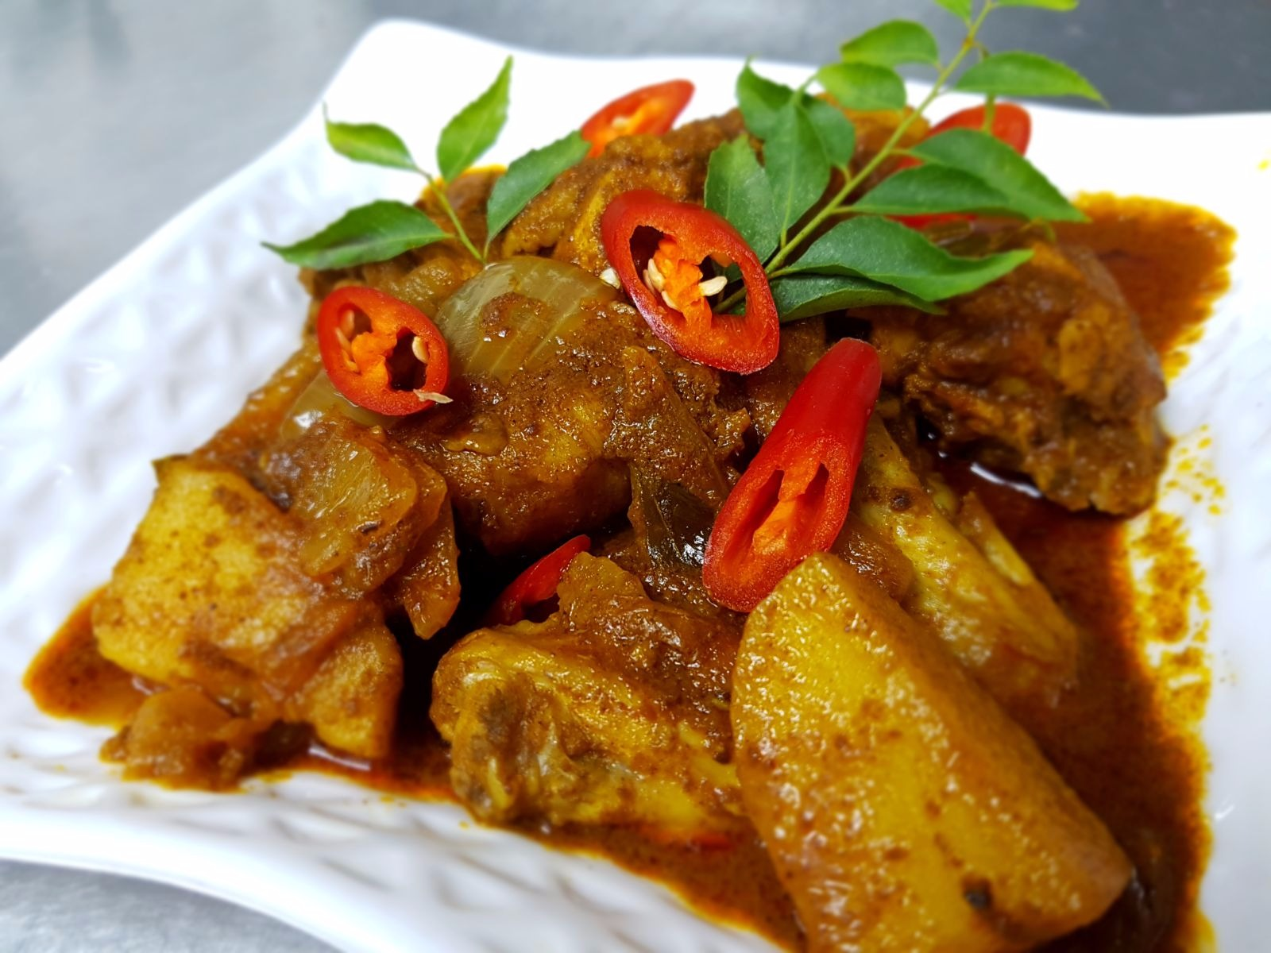

**INSTRUCTIONS**

1. First fried garlic and ginger, under the curry powder fried.

2 .Curry powders are roasted after adding curry leaves fried onions and peppers in the fried.

3. All saute and then put into chicken and potato add a little boiled roll.

4. Boil after adding tomato hot about it can be on the food.

(III) Original Western Cuisine

Carbonara

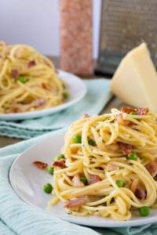

**INGREDIENTS**

* 1lb Spaghetti
* 2 tablespoons Sea Salt (for pasta water)
* 6 pieces Bacon (sliced into ½" strips)
* 4 cloves Garlic (minced)
* 3 Eggs
* 1.5 cups Fresh Grated Parmesan (plus extra for garnish)
* 1 cup Peas (optional)
* Black Pepper

**INSTRUCTIONS**

1. Get a large pot of sea salted water boiling and start cooking the spaghetti.
2. While your pasta is cooking, start cooking the bacon over medium heat in a large skillet. Cook until fat is rendered (about 4 minutes). Remove from heat.
3. Toss the garlic into the skillet with the bacon pieces. Stir so the garlic doesn't burn.
4. Whisk the eggs and parmesan together in a mixing bowl until the mixture is fairly lump free.
5. Take about a ½ cup of the boiling pasta water and slowly add it to the egg mixture while whisking quickly. You have to whisk quickly to temper the eggs. You should be left with a runny and smooth sauce.
6. If you want to add blanched peas to the skillet with the bacon, go ahead and do that now.
7. As soon as the pasta is done cooking, toss it directly into the skillet with the bacon fat, bacon, peas and garlic. Reserve at least a cup of the pasta water.
8. Toss the spaghetti into the bacon fat and then quickly add the egg and parmesan sauce to the noodles while mixing quickly.
9. Slowly add enough pasta water until the sauce is the desired consistency. (I usually use about a half cup)
10. Garnish with some fresh ground black pepper and top with extra parmesan (optional).

(III) ONW Recipe

Carbonara

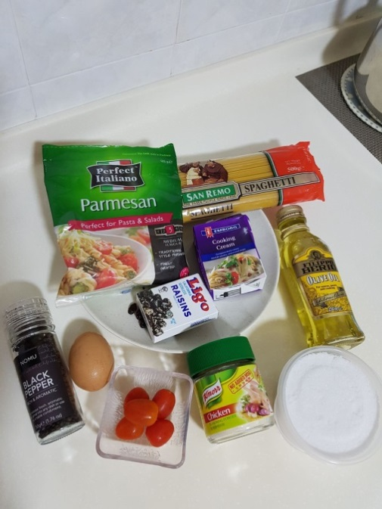

**INGREDIENTS**

* 1lb Spaghetti NO.5
* 2 tablespoons Sea Salt(for water)
* 1½ tablespoons Olive Oil
* 1½ tablespoons Chicken Powder
* 4 tablespoons Parmesan
* 75g Whipping Cream
* 1 Eggs
* 2 tablespoons Raisin
* 2 Cherry Tomato
* Black Pepper

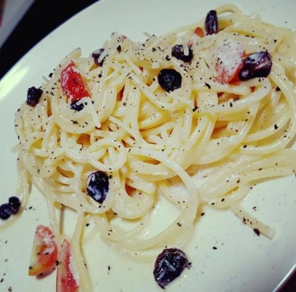

**INSTRUCTIONS**

1. Get a pot put sea salted in water boiling 10min take up.

2. Use a bowl put Whipping Cream, Parmesan and Egg then stir.

3. Use small fire heat up the pans, and then put Olive Oil fry Raisin.

4. Add the noodles in to the raisin and starts mixing then pour some water in to it.

5. After that put in the mixed whipping cream, parmesan and egg with low heat and stir it.

6. Lastly put in to the container with cut cherry tomato and black paper

**Conclusion**

After completing this assignment, I learn a lot of cooking skill and make use of my own creativity to create my own new cruise for Chinese, India and western. All the food is really tasty and healthy. Base on my understanding all the cruise and traditional food it comes with its own story. Base on this assignment, I found that healthy food is a must for nowadays. This is because new generations are relying on fast food which is unhealthy and not giant any benefit for body.

**References**

By Wes Radez, 22 January 2017 Online Source, How To Make Traditional Pork Dumplings. Retrieve from http://www.chineseamericanfamily.com/traditional-pork-dumplings/

By Unknown, Unknown Date, Online Source, Chicken Varuval Recipe. Retrieve from <http://www.indobase.com/recipes/details/chicken-varuval.php>

By Maria Ibbotson, 13 [JANUARY 2015](http://augustjoystudios.com/carbonara-recipe/#comment-200574), Online Source, Carbonara | Recipe. Retrieve from http://augustjoystudios.com/carbonara-recipe/